***Ahsanullah University of Science & Technology***

Department of Computer Science & Engineering



Seba-NGO Management System

# Information System Design &

Software Engineering Lab

**CSE-3224**

**Information Gathering**

**Quest**

**Submitted By**

# Ashfaq Ali Shafin 14.01.04.111

# Irtiza Abir 14.01.04.122

# Abid Hasan Prottoy 14.01.04.125

**Introduction:**

After completing the project proposal and project feasibility part successfully, we have decided to move on to the next phase of our project, which is the information gathering and representation with the following objectives in mind.

**Objectives:**

* Construct meaningful interview questions
* Understanding the client & organization’s view
* Understanding the current system
* Identify preferred transaction method
* Requirement & features Analysis
* Creating Use case diagram
* Creating data flow diagram

**For information gathering we have chosen three methods.**

1. Interviewed a professional from ASA NGO

* **Interview structure was Funnel type.**
* 9 open ended question in beginning.
* 4 close ended question after that.

1. Used Questionnaires to take survey from users
   * There were 9 questions in the survey and all of them were specific.
2. Investigation

* Quantitative

1. **Interview Information:**

|  |  |  |  |
| --- | --- | --- | --- |
| Seba – NGO Management System | | | |
| **Author:**  Ashfaq Ali Shafin  Abid Hasan Prottoy  Irtiza Abir | **Date: 08/12/2016** | **Time**: 12:005 pm | **Duration:** 20 mins |
| **Participants:** Mr. Tanjeer Bin Haque  Lead Software Engineer at ASA | | **Comments:** Currently in a human information gathering process of NGO operation system in general format. | |

**Reason for selecting the Professional:**

Mr. Tanjeer Bin Haque is the Lead Software Engineer at ASA. He is working in ASA since last year. So, he knows well about how ASA runs their program and operates them. Moreover, he has a vast knowledge of NGO management system.

**Total Interview Procedure:**

**Question 01: How ASA operates their program?**

Answer: ASA is not a donor based NGO. We are self-financed in most of the projects now. But in the past like in 1970-1980 donation system was available for the organization.

**Question 02: In which projects you grant a donor?**

Answer: Some projects like sanitization, agricultural development, we accept donation from different organizations like World Bank, Save the Children.

**Question 03: Why does World Bank/Save the Children collaborate with NGO?**

Answer: The clients of NGO are mostly under developed and live in rural areas. Sometimes it is a difficult task for the donors to reach their desired clients. So we merge together for some particular projects like Sanitization, Agricultural development etc.

**Question o4: What is the process behind selecting the clients?**

Answer: We have distributed branches all over Bangladesh. So, in a particular area there are Branch Managers and Area Managers who select the clients. Most of the times these managers are local. So they analyze the whole process to find out the eligible candidates for the loan program. Sometimes it is preferable to select a client with a reference from other trusted clients.

**Question 05: Is there any other criteria, that is followed to select a client for the micro-finance activity like their potential level, poverty level etc?**

Answer: Yes, we select those candidates who are willing to change their current poverty level and utilize resources potentially.

**Question 06: How does branch manager communicate with main branch? Is there a web based system for that?**

Answer: No, we don’t have any direct web based system for that. Desktop based system is used for branches. Branch managers collect information and store them at the desktop system.

**Question 07: How does a member communicate with the system?**

Answer: For getting the loan the member must come to the area branch to collect the loan. After that they communicate through the area operator. An area operator is assigned for a group of 30-35 people. They meet in a common place weekly to be updated. Then the areaoperator takesthe updated information in a register notebook. This information then stored in the system from the register book.

**Question 08: Isn’t it an old manual process?**

Answer. Yes, it is. But recently we have taken some initiative to the automation process. Currently in Dhaka, we have distributed Android Tablets to the Area Operators which is used for collecting data and information. This is not fully functional to the whole country. By the time of 2018, the full process will be automated. But it has some obstacles.

**Question 09: What are the obstacles we are talking about?**

Answer: It is difficult to have an internet connection in the rural areas where not even electricity is provided.

**Question 10: Can the clients get the current information of the activity through the web?**

Answer: No, currently we do not have that.

**Question 11: So how can the clients get the current information of the activity?**

Answer: By the area manager and area operator.

**Question 12: What method is used by the main branch to collect the information from the local branches?**

Answer: It is an automated process. We collect the information on a monthly basis.

**Question 13: Which program of ASA has the most members?**

Answer: Micro-finance.

1. **Questionnaire (Users):**

What general people think about NGO were collected using a questionnaire made by <https://docs.google.com/forms> . The questionnaires were directed at users via social media, so the data was collected from random users. As our website’s main target is to interact with people, it will be made to suit the preference of the users.

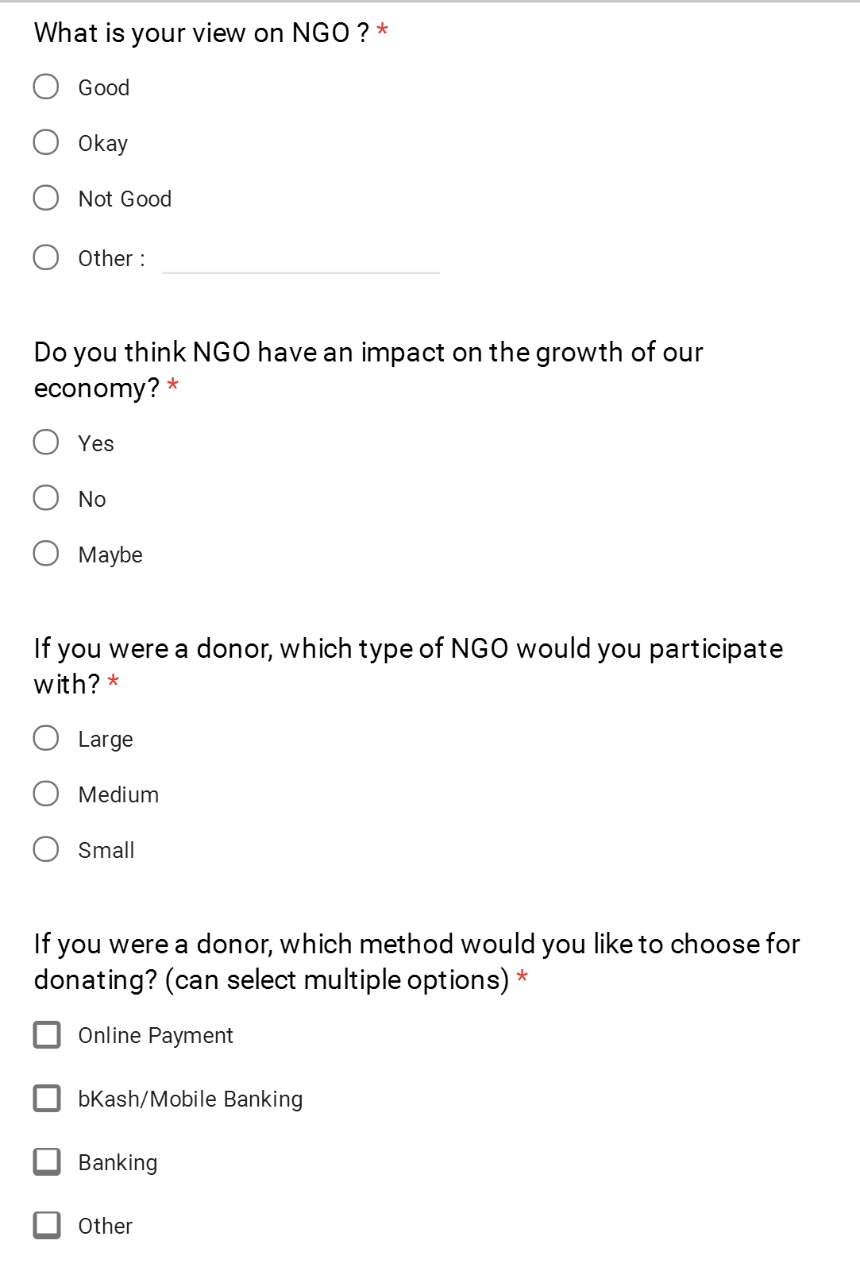

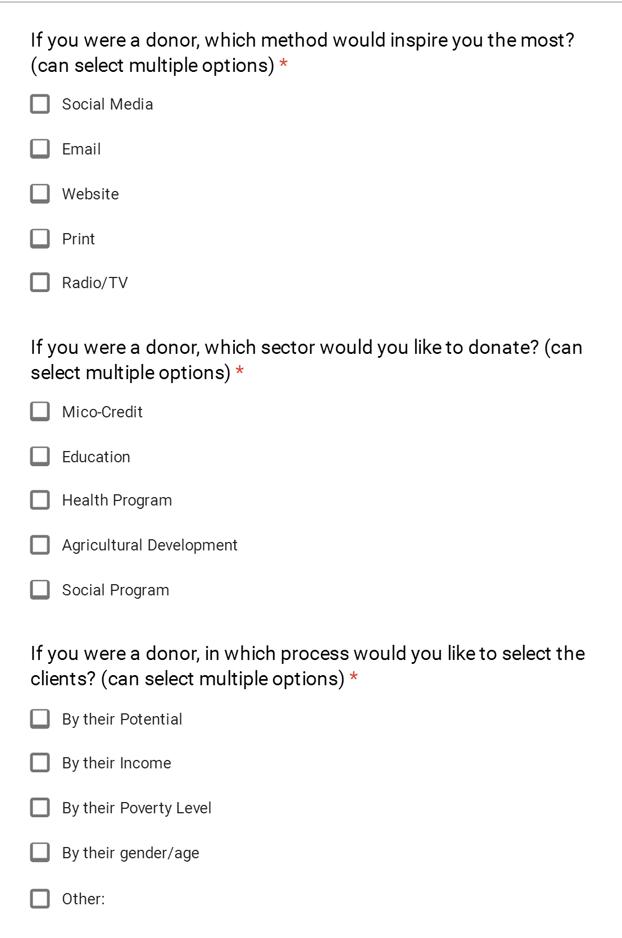

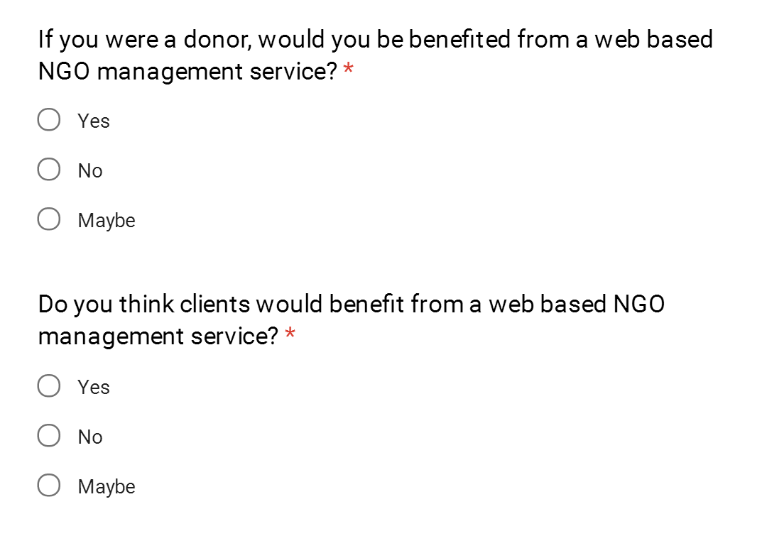

1. **Investigation:**

This process was based on a research paper**[1]**

* Bangladesh is in the top 3rd country in Asia having most of the NGO.
* Top 5 causes are: Education, Children & Youth, Women & Girls, Health & Safety and Civil Rights
* NGOs in Asia: 2016 Online Technology Benchmarks
* **26%** of NGOs in Asia assign the responsibility of social media management to a communications staff person. **14%** have a full-time or part-time social media manager. **17%** depend upon volunteers. The remaining **43%** assign the responsibility to development, program, administrative, and/or executive staff.
* **86%** agree that social media is effective for online fundraising.

**Revised Requirement Analysis:**

After a detailed analysis of the interview of the professional and the questionnaires answered by the people from survey, we have revised our requirement analysis. The followings have to be appended to our initial requirement analysis

* Most of the people think that NGO have an impact on our economy growth.
* The donor would like to participate with medium type of NGO.
* The Donor would prefer Banking system for donation.
* Donor would like to donate in our education system most.
* Donor & professional both think it would be highly benefited if there is a web based system for the NGO.

**Summary:**

Two major changes are being made after this information gathering part.

1. Donor online payment system was not included in our primary proposal. Now that we have found out the majority of donations we are going to implement this process.
2. Advertisement option for members were proposed but for donors there were no option. So now we will be featuring that part.

**Conclusions:**

This concludes phase 2 of our web development process. This report helped us communicate our processes of implementing the web system and made ourselves aware of how information is being processed. We also get a clear overview about what features we should keep in our website to interact with the common people.

**Appendix**

**Result of the Questions:**

1. What is your view on NGO?

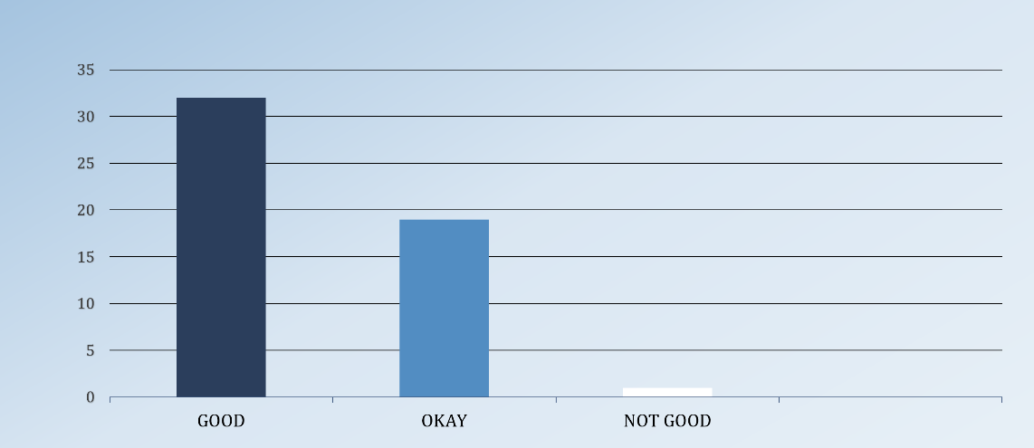

1. Do you think NGO have an impact on the growth of our economy?

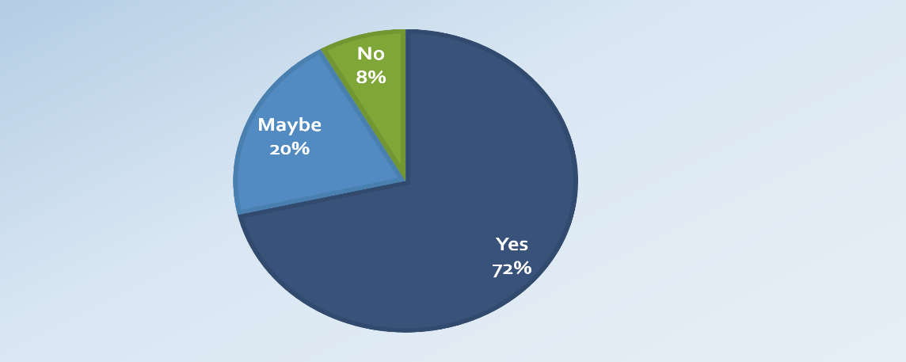

1. If you were a donor, which type of NGO would you participate with?

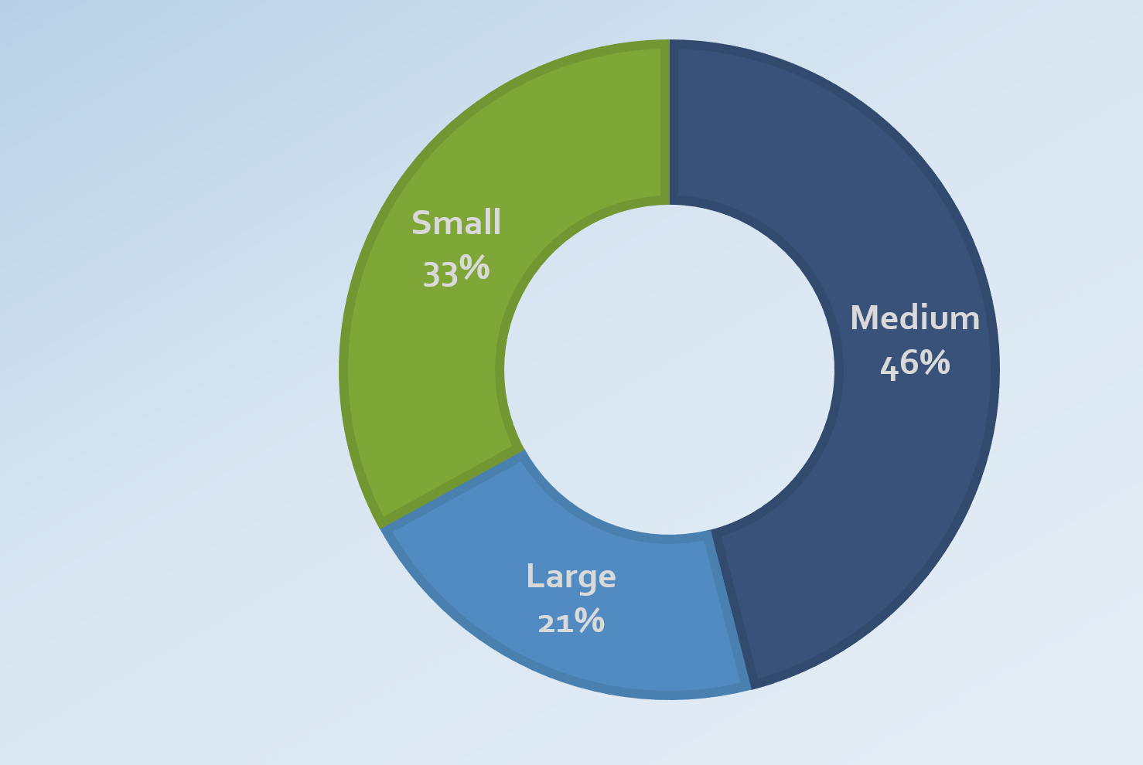

1. If you were a donor, which method would you like to choose for donating? (can select multiple options)

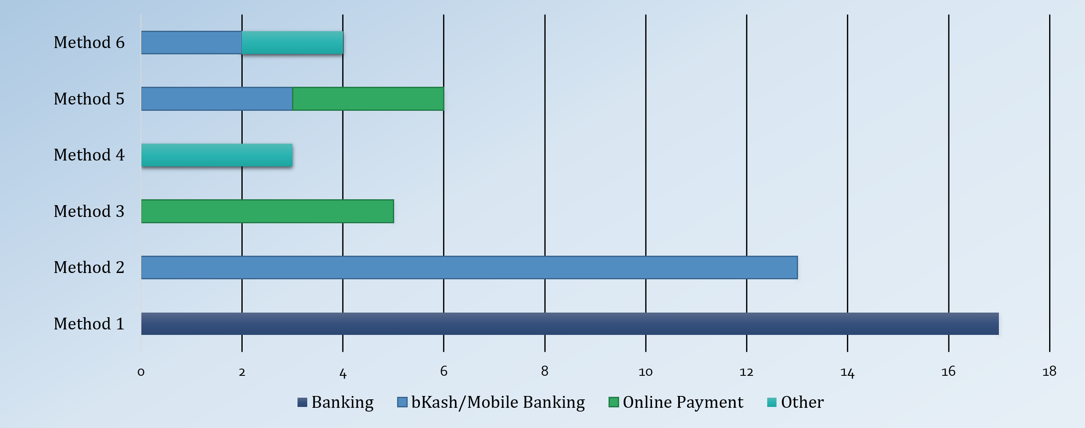

1. If you were a donor, which method would inspire you the most? (can select multiple options)

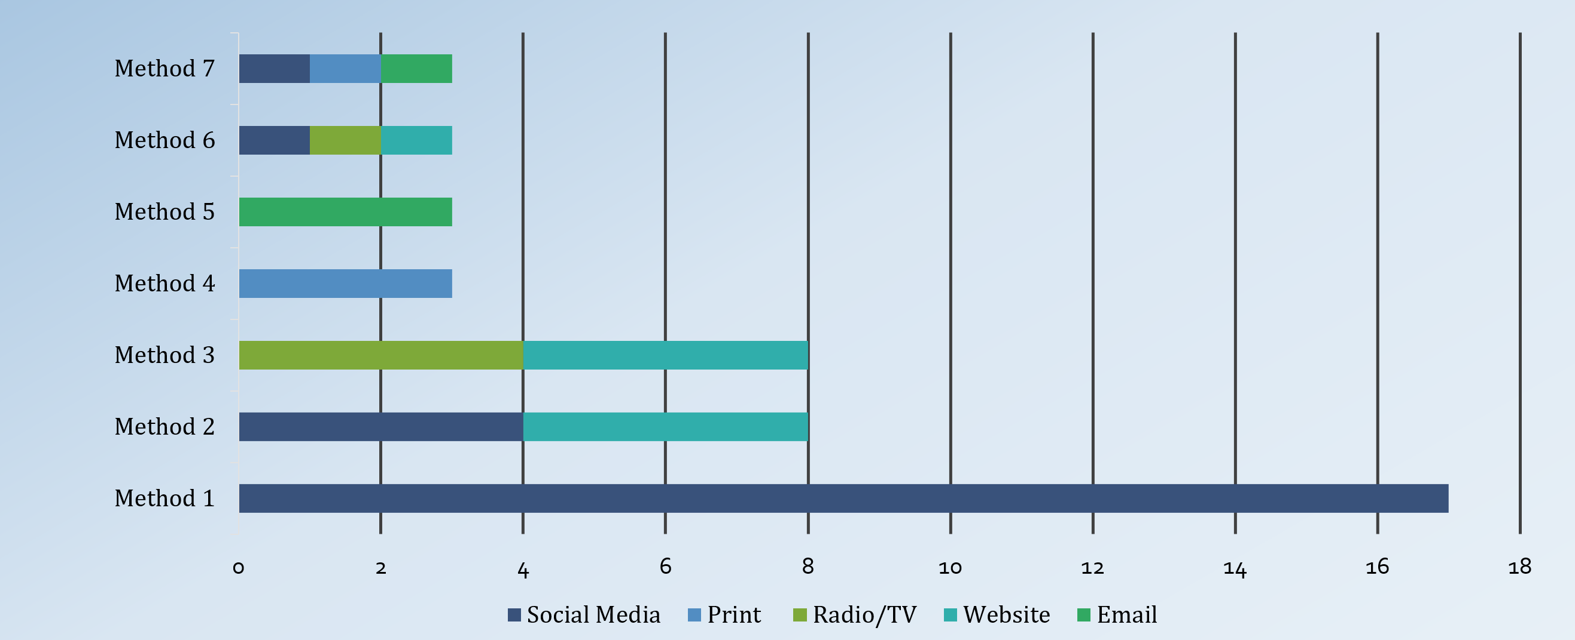

1. If you were a donor, which sector would you like to donate? (can select multiple options)

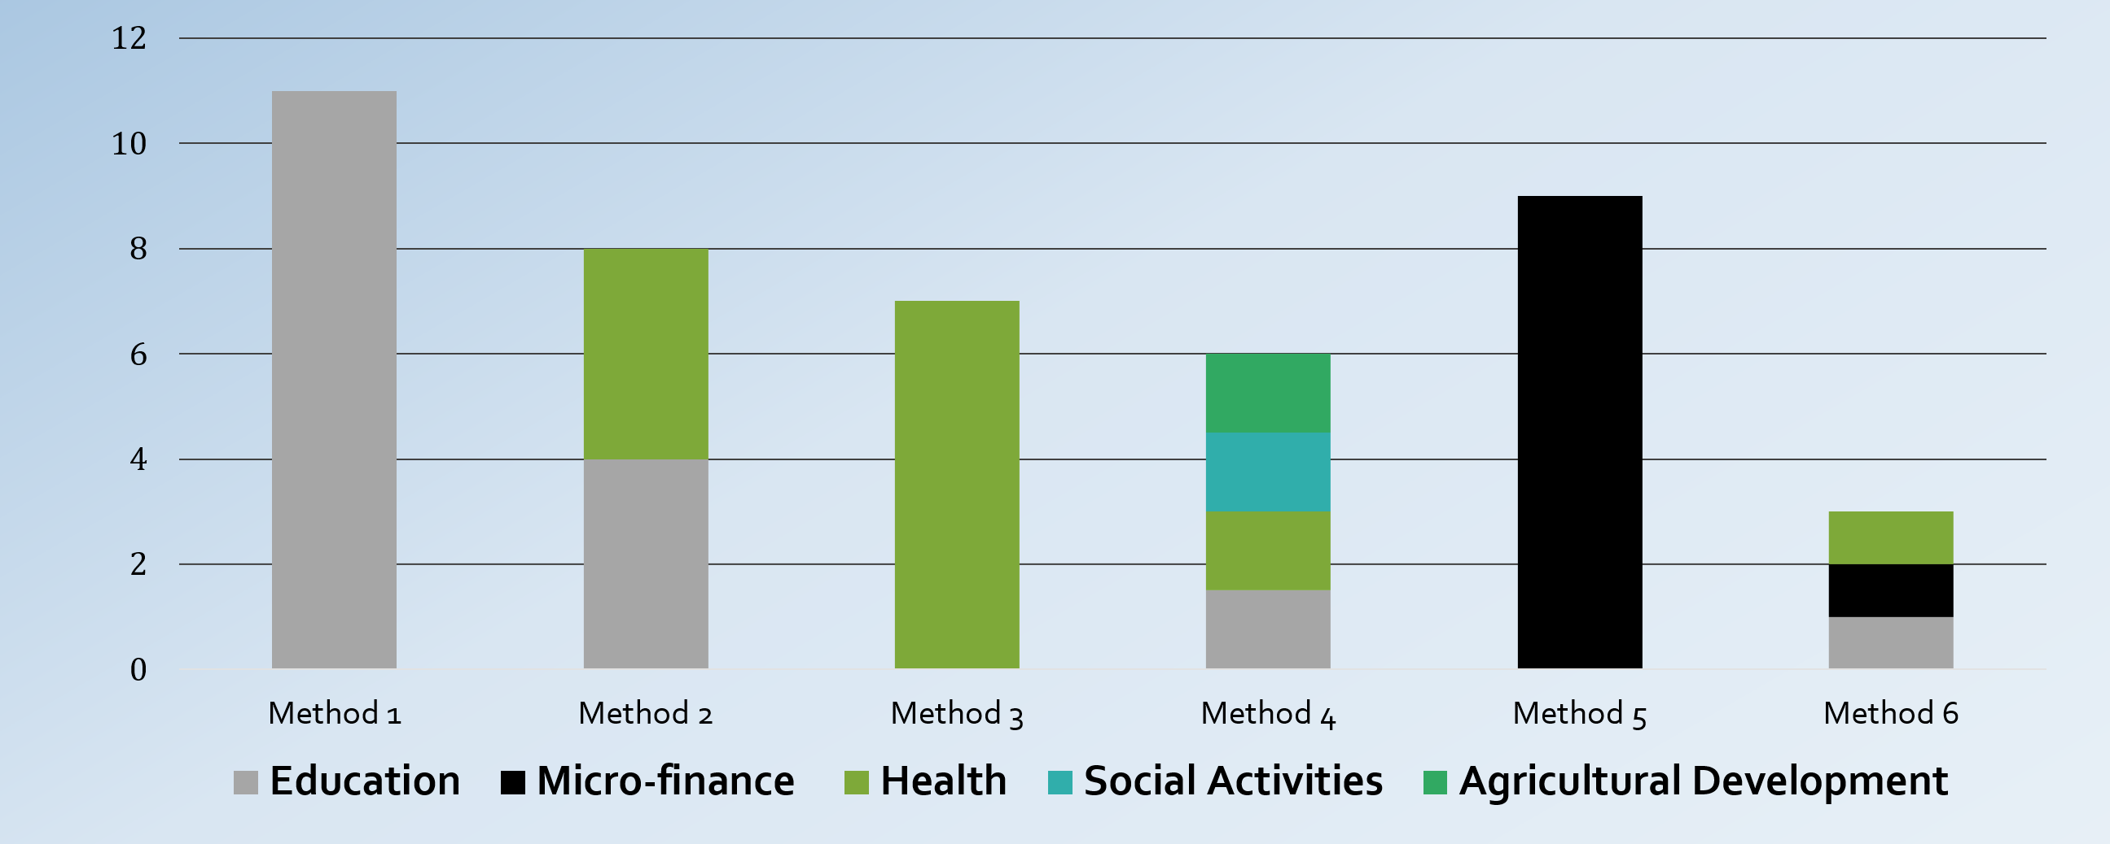

1. If you were a donor, in which process would you like to select the clients? (can select multiple options)

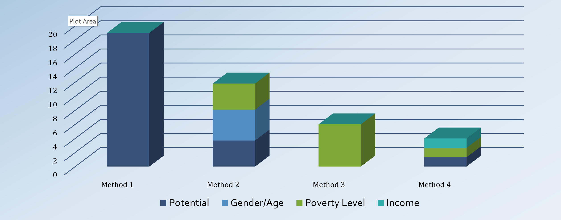

1. If you were a donor, would you be benefited from a web based NGO management service?

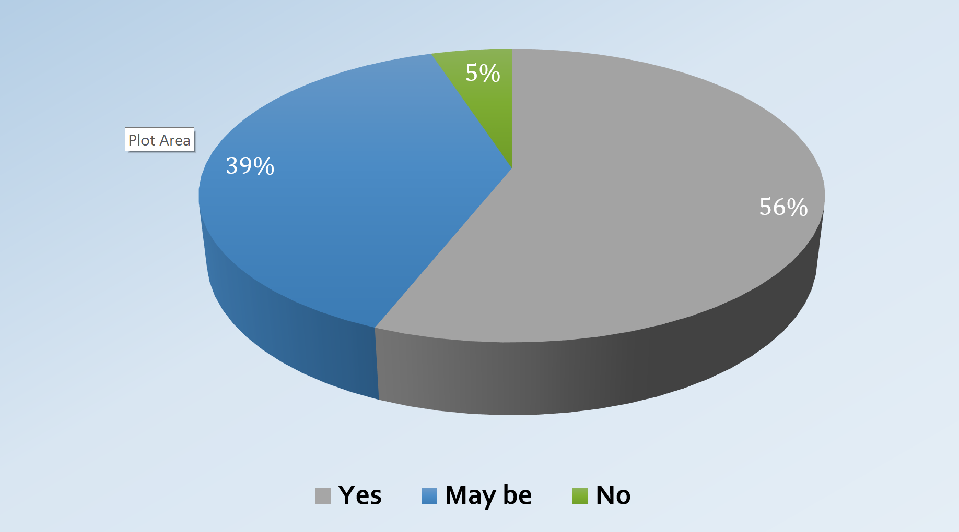

1. Do you think clients would benefit from a web based NGO management service?

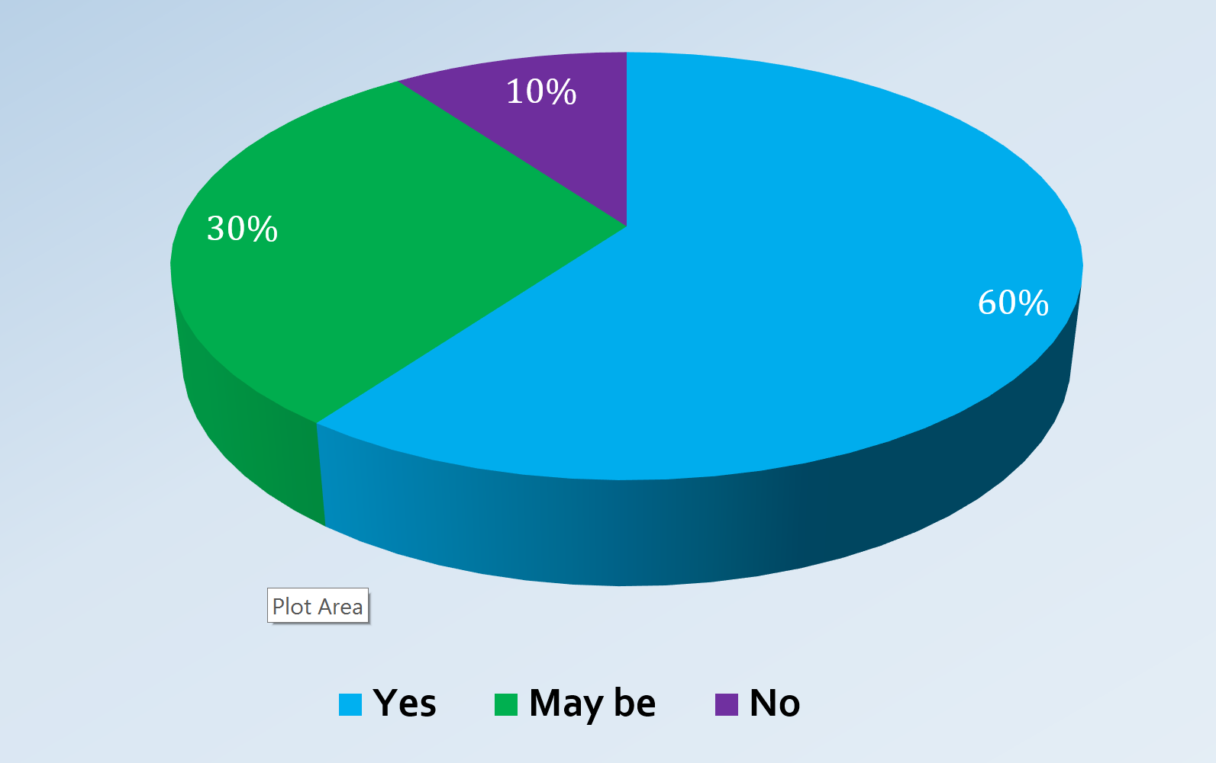

1. Annual Report of the research 2016 Global NGO Online Technology. <http://bit.ly/1nyG08a>